EXPENSEIQ – AI-POWERED PERSONAL EXPENSE TRACKER

PROBLEM STATEMENT :
Many individuals find it difficult to effectively manage their personal finances due to the increasing number of daily transactions and expenses. They often fail to maintain a proper record of their income and spending, making it challenging to understand where their money is being spent. This lack of financial tracking can lead to overspending, poor budgeting, reduced savings, and difficulty in achieving financial goals. Traditional methods such as maintaining notebooks or spreadsheets are time-consuming, prone to errors, and do not provide meaningful insights into spending patterns. Additionally, users often lack personalized guidance that can help them identify unnecessary expenses and make better financial decisions.

PROPOSED SOLUTION :
The proposed solution is a smart personal expense management system that helps users efficiently organize and monitor their financial activities in one place. The application allows users to securely manage their income and expenses, categorize transactions, track monthly budgets, and view financial summaries through an intuitive dashboard. It also provides detailed spending analysis and personalized financial recommendations based on users' spending habits, enabling them to identify unnecessary expenses and improve their saving practices. By offering real-time insights, organized financial records, and intelligent suggestions, the system promotes better budgeting, informed financial decision-making, and overall financial well-being.

TECHNOLOGY STACK :
Category | Technology
Frontend | HTML5, CSS3, JavaScript (ES6), Bootstrap 5
Backend | Node.js, Express.js
Database | MongoDB Atlas, Mongoose (ODM)
Authentication | JSON Web Token (JWT), bcrypt.js
AI Integration | Groq API (Llama Model)
API Testing | Postman
Version Control | Git, GitHub
Deployment | Vercel (Frontend), Render (Backend), MongoDB Atlas (Database)
ARCHITECTURE DIAGRAM :
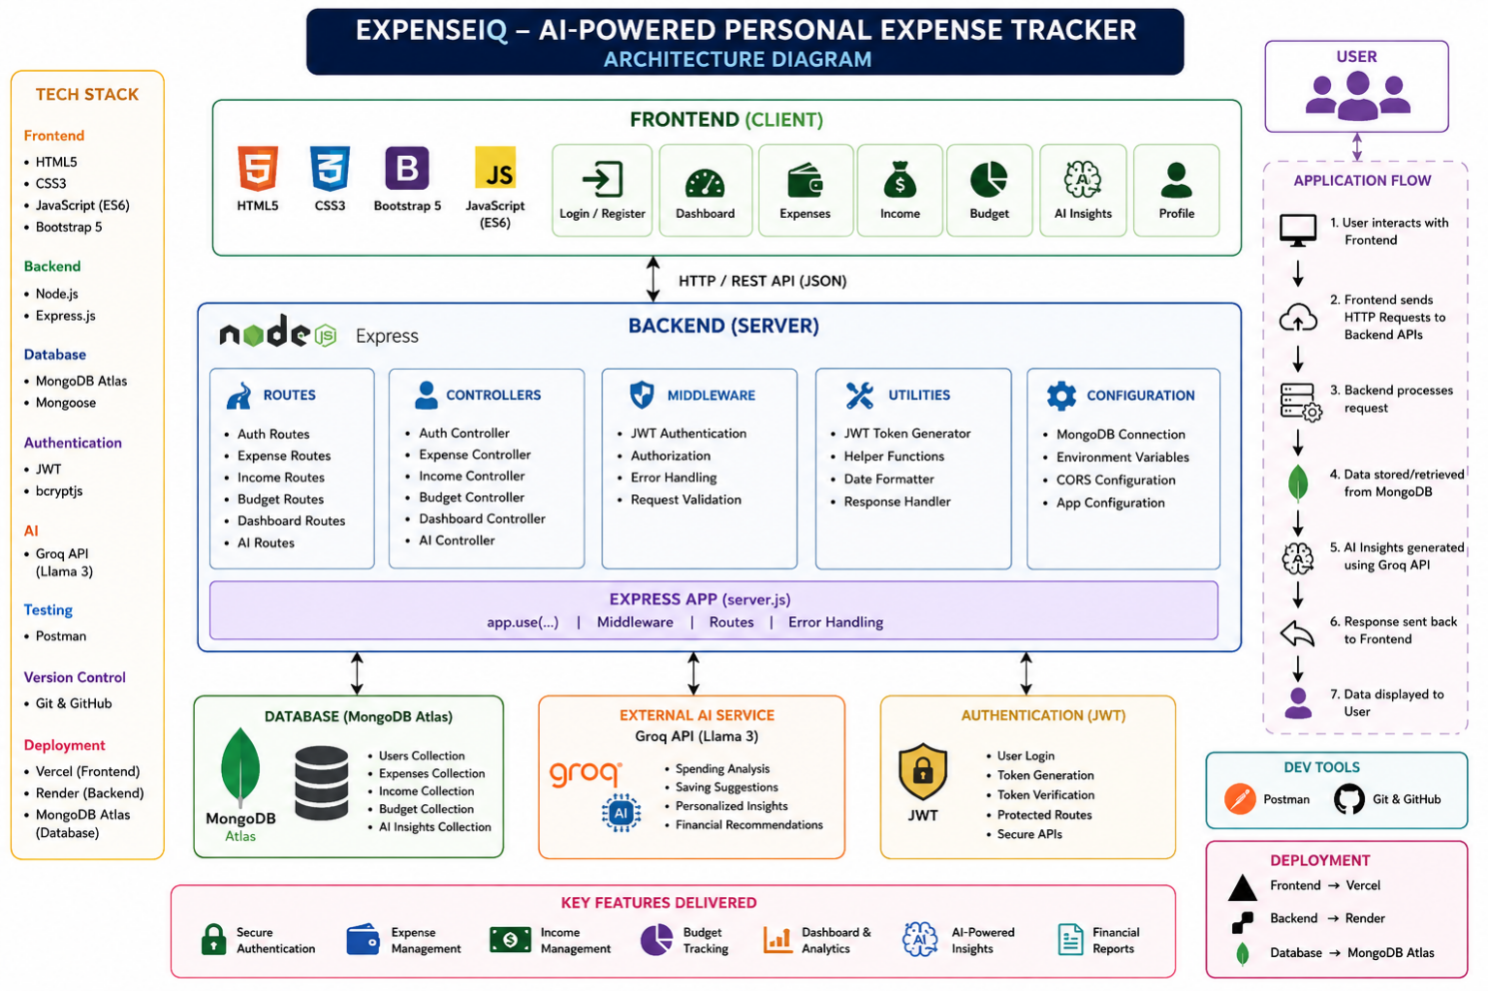
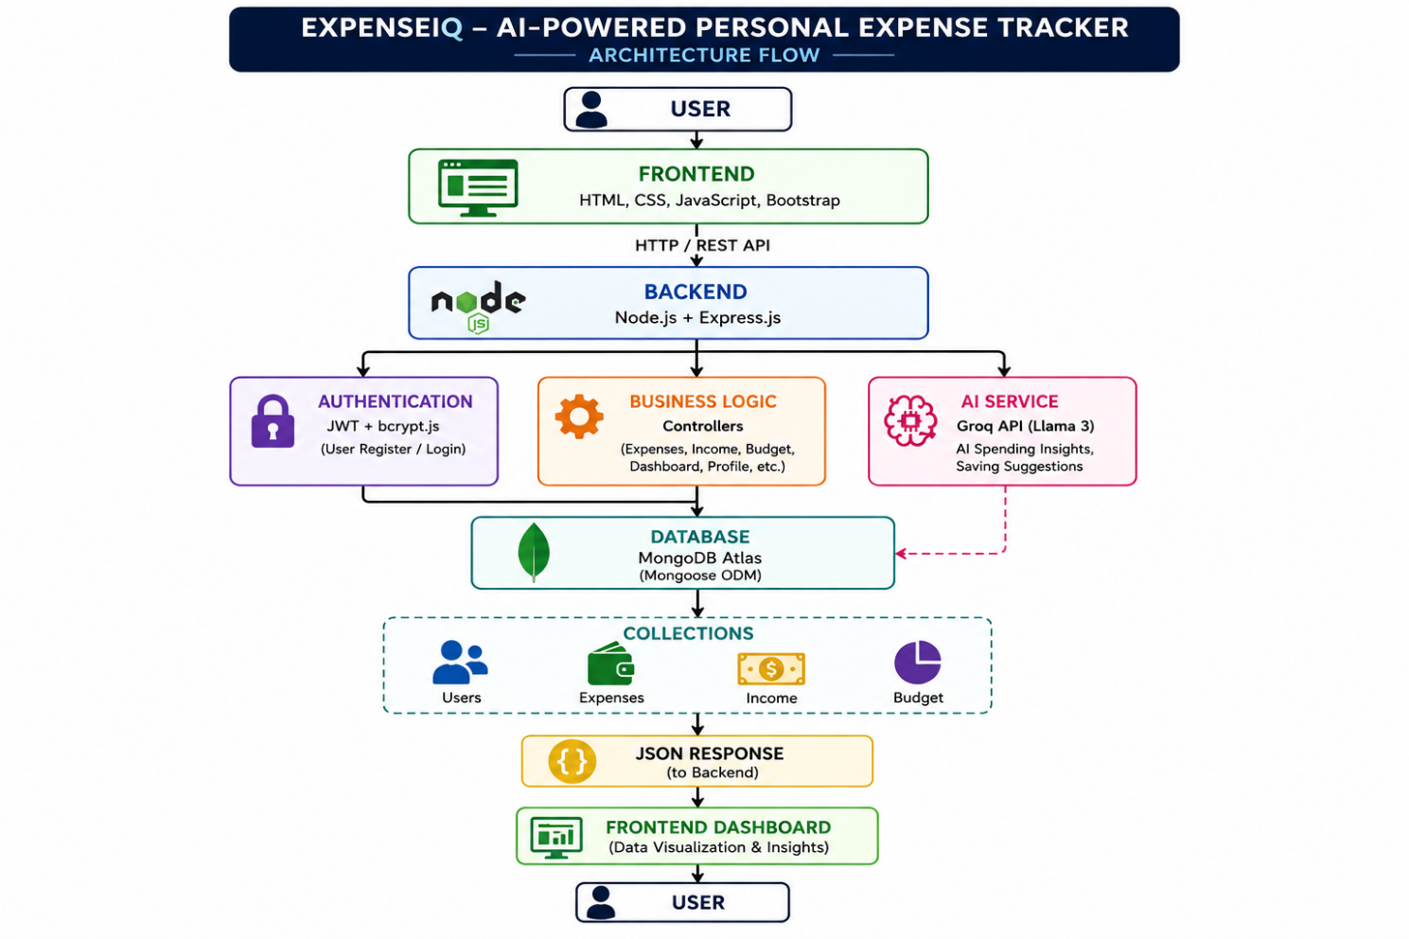
OVERALL FLOWCHART :
User
│
▼
Frontend (HTML, CSS, JS)
│
▼
Express REST API
│
├── JWT Authentication
├── Business Logic (Controllers)
├── MongoDB Operations (Mongoose)
└── Groq AI Integration
│
▼
MongoDB Atlas + Groq AI
│
▼
JSON Response
│
▼
Frontend Dashboard
PROJECT FOLDER STRUCTURE :
ExpenseIQ/
│
├── backend/
│ ├── config/
│ │ └── db.js
│ │
│ ├── controllers/
│ │ ├── authController.js
│ │ ├── expenseController.js
│ │ ├── incomeController.js
│ │ ├── budgetController.js
│ │ ├── dashboardController.js
│ │ ├── profileController.js
│ │ └── aiController.js
│ │
│ ├── middleware/
│ │ ├── authMiddleware.js
│ │ └── errorMiddleware.js
│ │
│ ├── models/
│ │ ├── User.js
│ │ ├── Expense.js
│ │ ├── Income.js
│ │ └── Budget.js
│ │
│ ├── routes/
│ │ ├── authRoutes.js
│ │ ├── expenseRoutes.js
│ │ ├── incomeRoutes.js
│ │ ├── budgetRoutes.js
│ │ ├── dashboardRoutes.js
│ │ ├── profileRoutes.js
│ │ └── aiRoutes.js
│ │
│ ├── utils/
│ │ └── generateToken.js
│ │
│ ├── .env
│ ├── .gitignore
│ ├── package.json
│ ├── package-lock.json
│ └── server.js
│
├── frontend/
│ ├── assets/
│ │ ├── images/
│ │ └── icons/
│ │
│ ├── css/
│ │ ├── style.css
│ │ ├── dashboard.css
│ │ └── auth.css
│ │
│ ├── js/
│ │ ├── auth.js
│ │ ├── dashboard.js
│ │ ├── expense.js
│ │ ├── income.js
│ │ ├── budget.js
│ │ ├── profile.js
│ │ ├── ai.js
│ │ └── api.js
│ │
│ ├── pages/
│ │ ├── login.html
│ │ ├── register.html
│ │ ├── dashboard.html
│ │ ├── expenses.html
│ │ ├── income.html
│ │ ├── budget.html
│ │ └── profile.html
│ │
│ └── index.html
│
├── README.md
└── LICENSE

PROJECT DEVELOPMENT PHASES :
Phase 1: Project Setup
- Create project folder structure
- Initialize Node.js project
- Install required dependencies
- Configure project files and environment
Phase 2: Backend Configuration
- Set up Express.js server
- Connect to MongoDB Atlas
- Configure environment variables
- Test server and database connection
Phase 3: User Authentication
- Design User model
- Implement user registration
- Implement user login
- Password hashing and JWT authentication
- Logout functionality
Phase 4: Expense Management
- Create Expense model
- Add expense
- View all expenses
- Edit expense
- Delete expense
Phase 5: Income Management
- Create Income model
- Add income
- View income history
- Edit income
- Delete income
Phase 6: Dashboard
- Display total income
- Display total expenses
- Calculate current balance
- Display recent transactions
- Show transaction count
Phase 7: Search and Filter
- Search transactions by title
- Filter by category
- Filter by date
- Sort by amount or date
Phase 8: Budget Management
- Set monthly budget
- Track remaining budget
- Display budget warning when limit exceeds
Phase 9: Expense Analytics
- Category-wise expense analysis
- Monthly expense summary
- Income vs. expense comparison
- Interactive charts and graphs
Phase 10: AI Spending Insights
- Analyze spending patterns
- Identify highest spending category
- Generate monthly financial summary
- Provide personalized saving recommendations
Phase 11: User Profile
- View profile details
- Update profile information
- Change password
Phase 12: Frontend Development
- Design responsive user interface
- Create authentication pages
- Build dashboard and management pages
- Integrate frontend with backend APIs
Phase 13: Testing
- Test all APIs using Postman
- Perform functional testing
- Validate user authentication and CRUD operations
Phase 14: Deployment
- Deploy frontend
- Deploy backend
- Connect cloud database
- Perform final testing and verification

PHASE 1: PROJECT SETUP
Create the Project Folder :
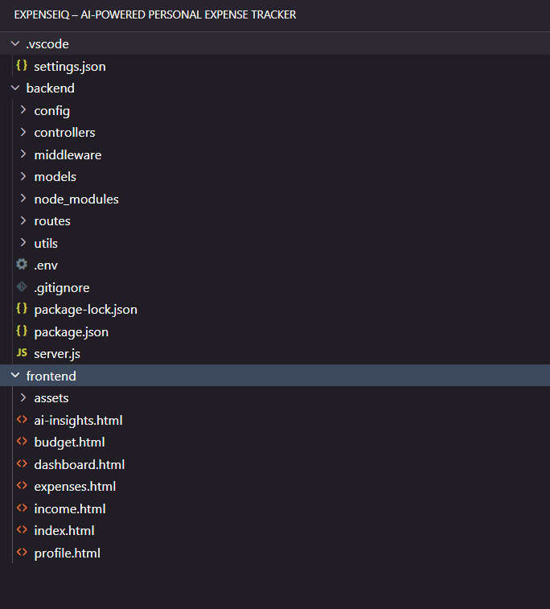

Step 2 :Install Dependencies :
1. Initialize Node.js Project
npm init -y
2. Install Express
npm install express
3. Install Mongoose
npm install mongoose
4. Install Dotenv
npm install dotenv
5. Install CORS
npm install cors
6. Install bcrypt.js
npm install bcryptjs
7. Install JWT
npm install jsonwebtoken
8. Install Groq SDK
npm install groq-sdk
9. Install Nodemon (Development Dependency)
npm install --save-dev nodemon

Verify Installation
npm list --depth=0

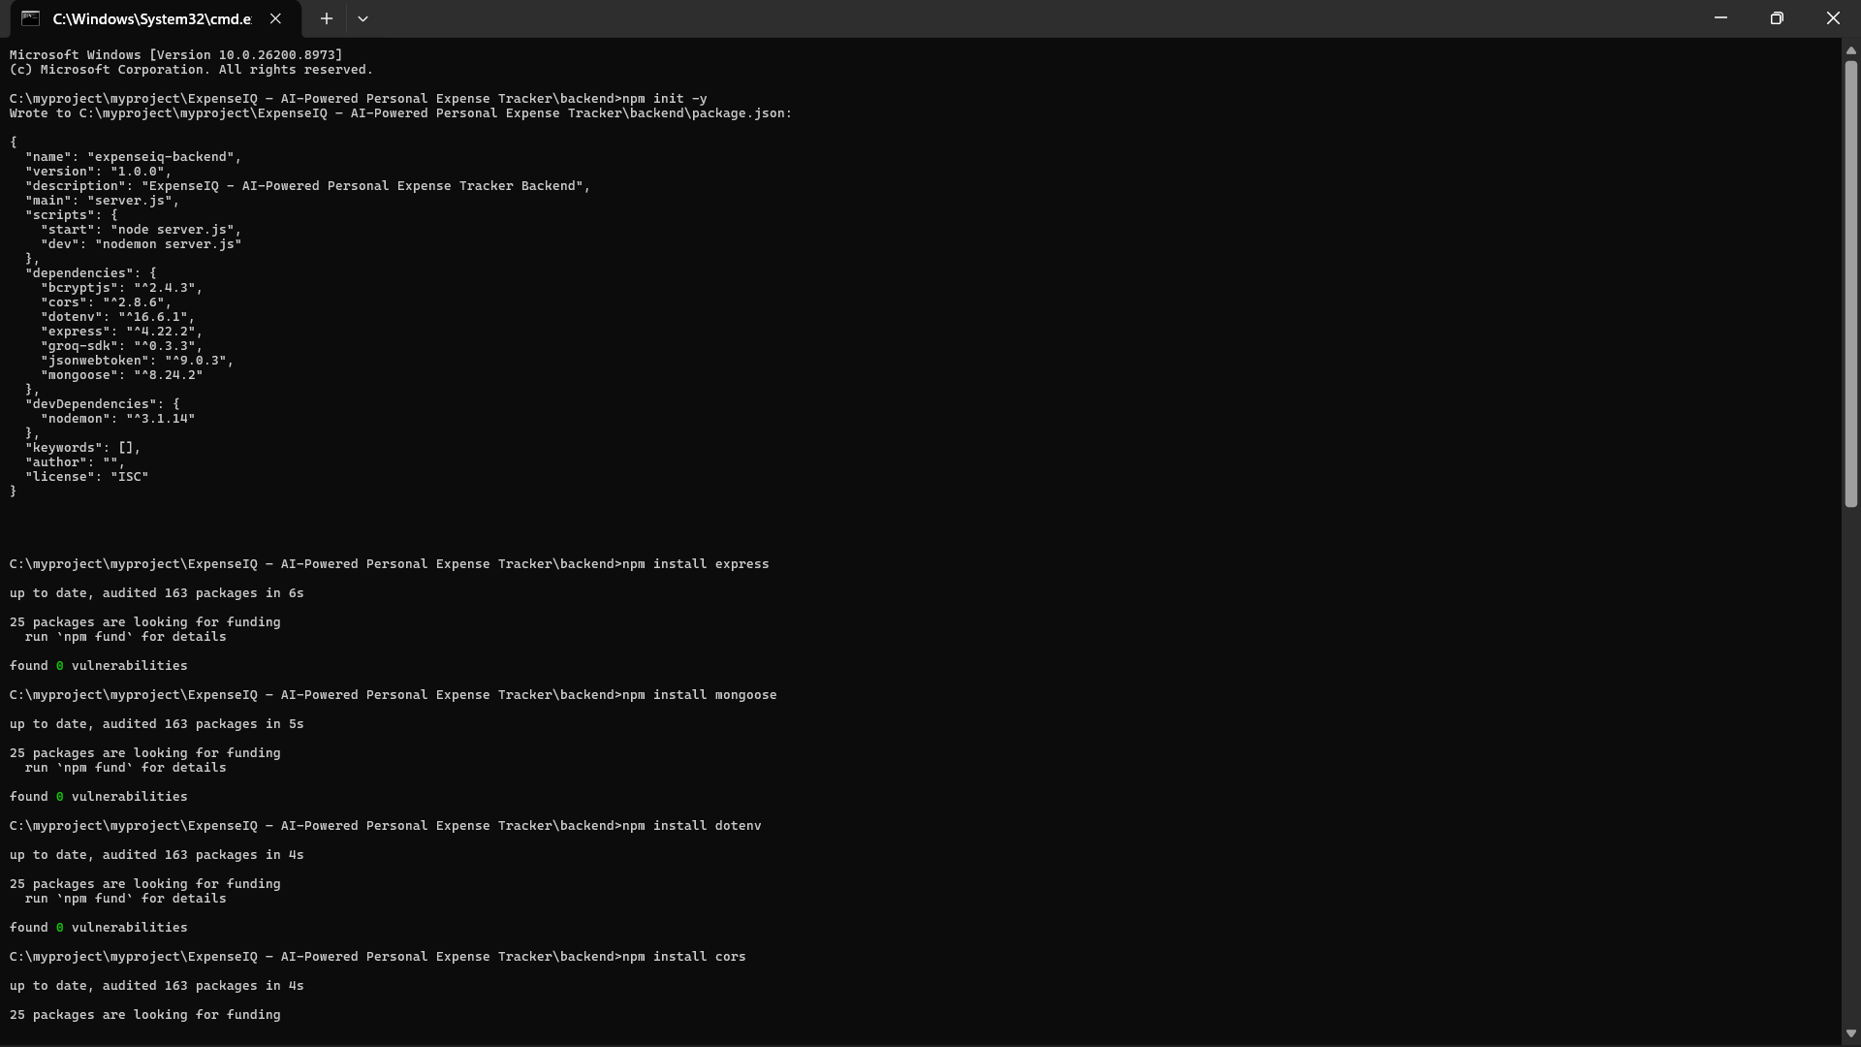

GIT REPOSITORY :
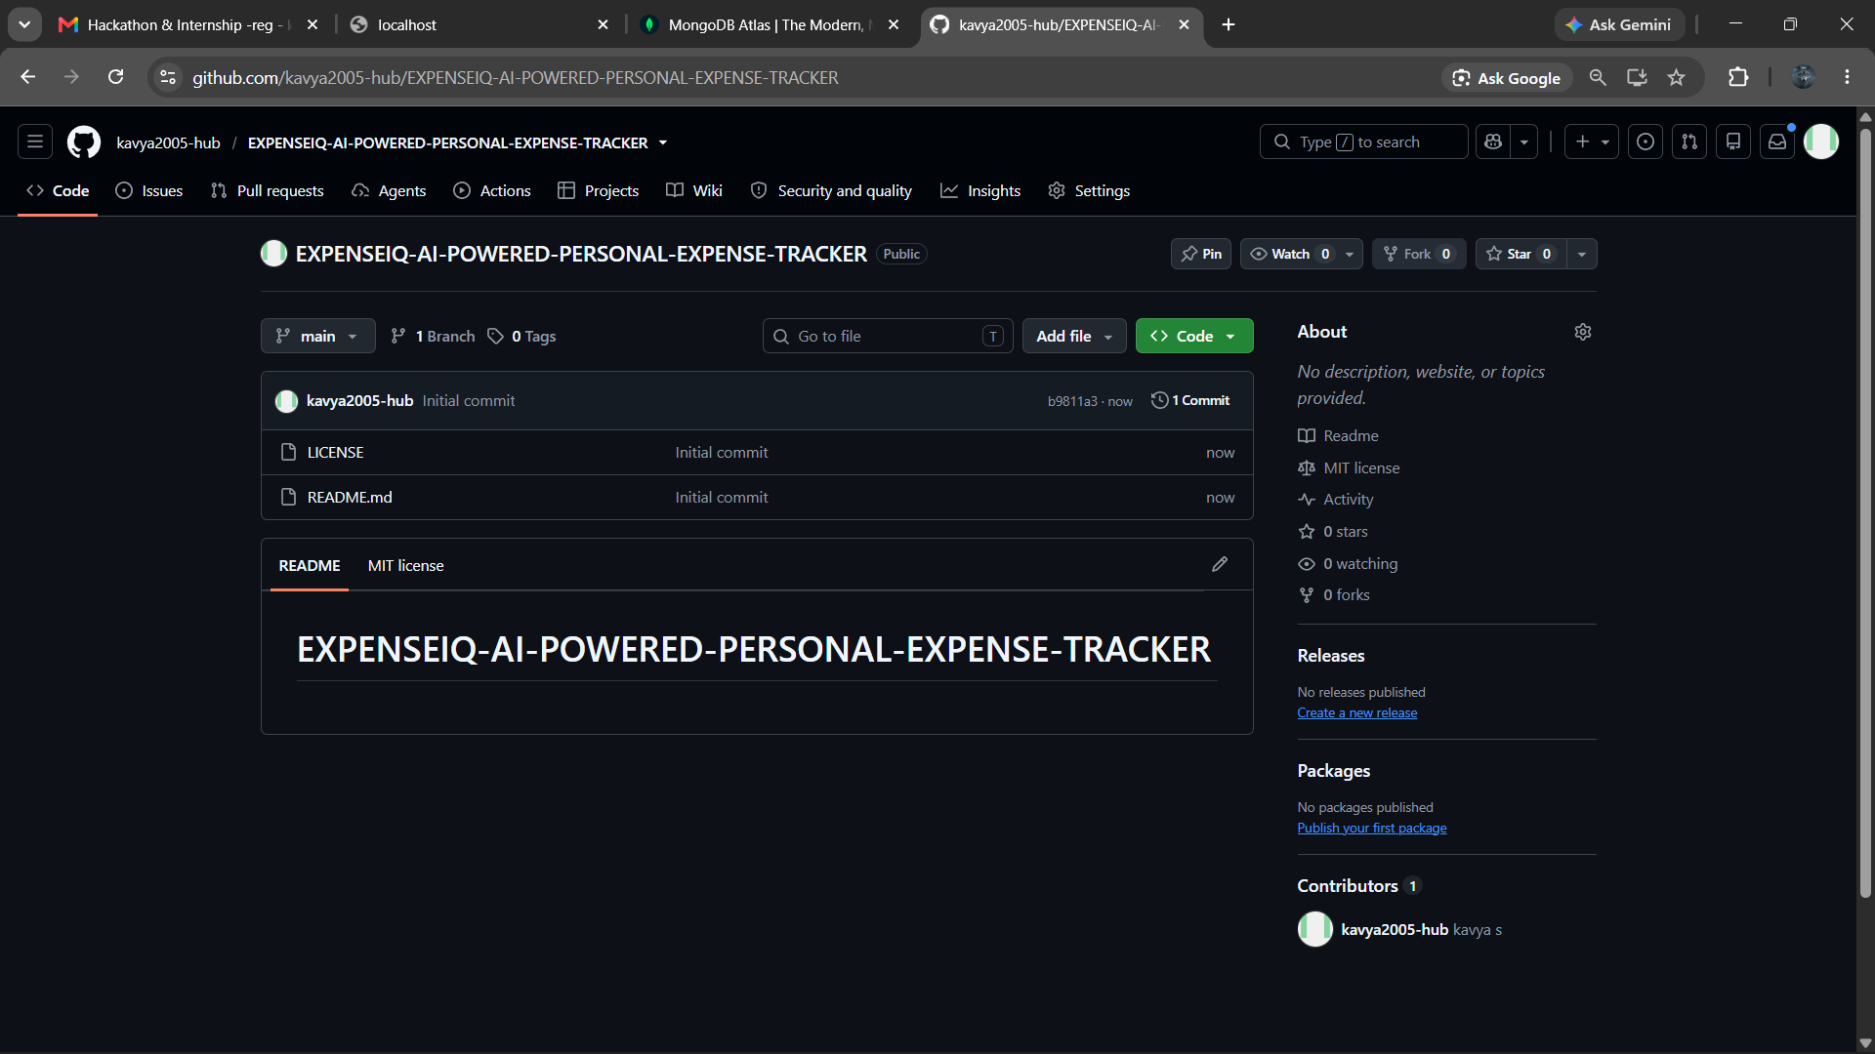
git init
git add .
git commit -m "Initial commit"
git branch -M main
git remote add origin https://github.com/kavya2005-hub/EXPENSEIQ-AI-POWERED-PERSONAL-EXPENSE-TRACKER
git push -u origin main
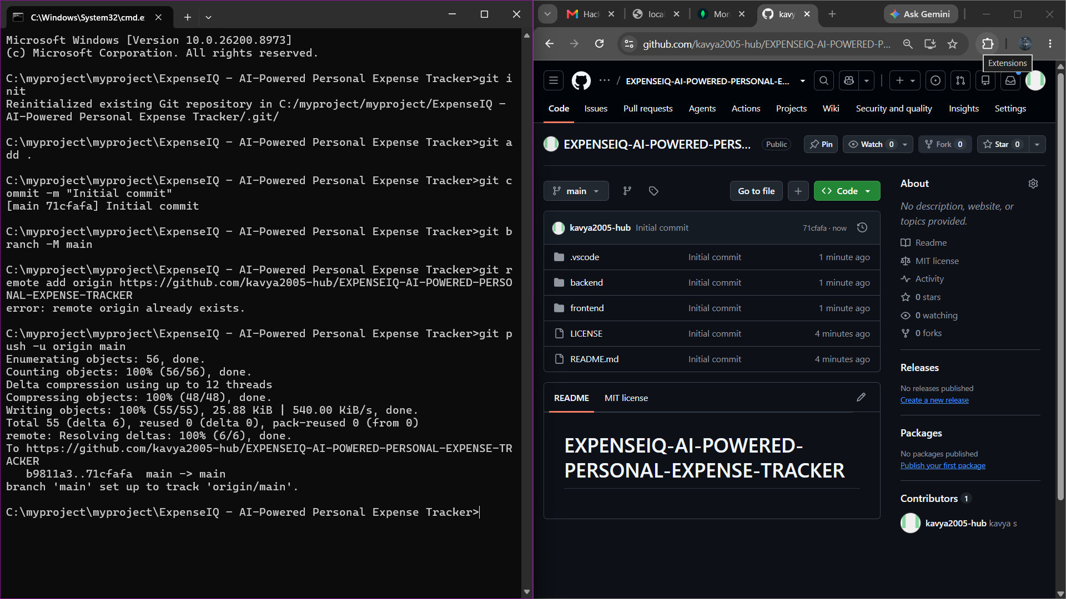

MONGODB ATLAS SETUP :

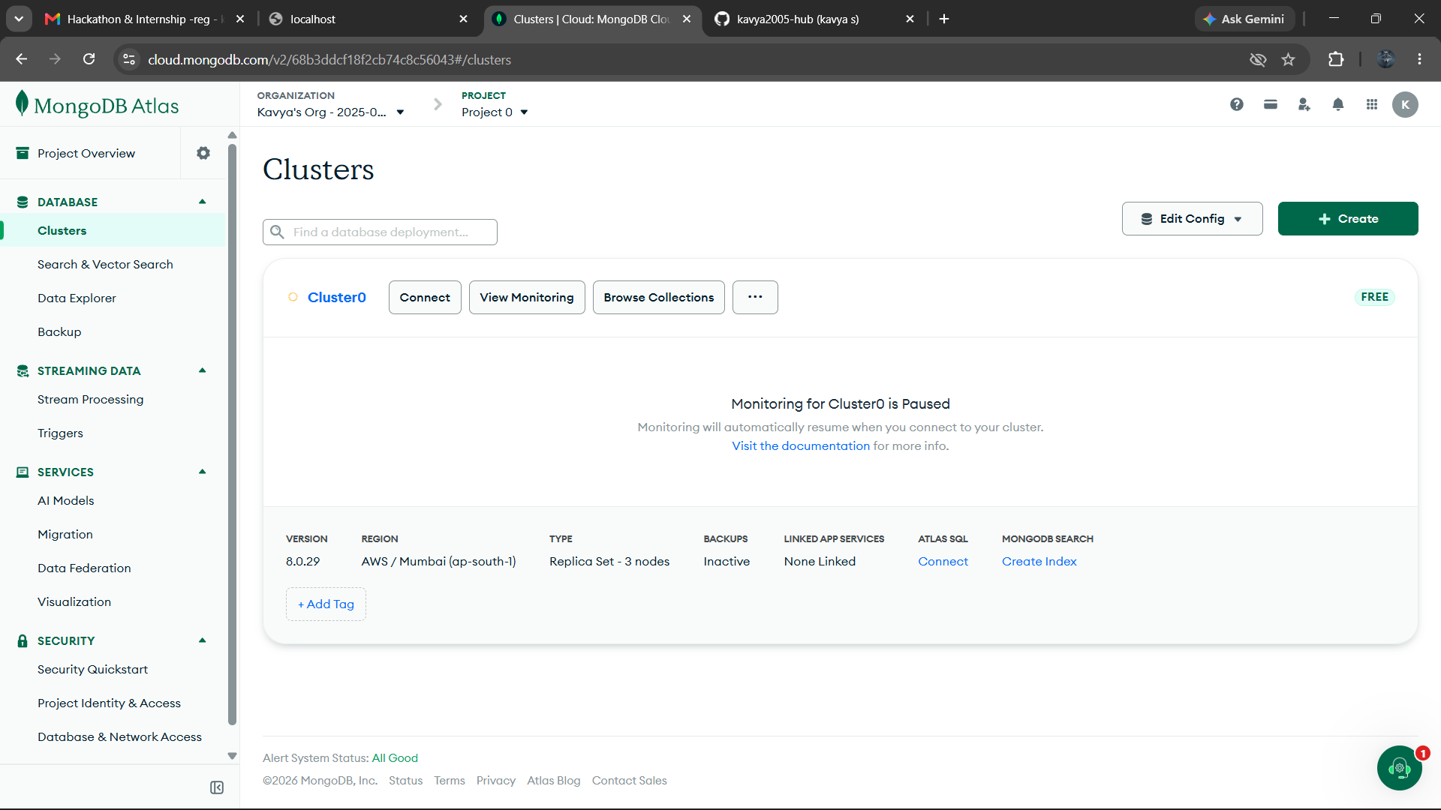
PHASE 3: USER AUTHENTICATION :
Objective
Implement a secure authentication system so users can register, log in, and access protected resources.

Features Covered
Step 1: Create User Model
- Create User.js
- Define user schema
- Add validations
Step 2: Register API
- Create registration controller
- Validate user input
- Check if email already exists
- Hash password using bcryptjs
- Save user to MongoDB
Step 3: Login API
- Verify email
- Compare password using bcryptjs
- Generate JWT token
- Return user details and token
Step 4: JWT Authentication
- Create generateToken.js
- Create authMiddleware.js
- Protect private routes
Step 5: Authentication Routes
- Create authRoutes.js
- Register endpoint
- Login endpoint
Step 6: Test Using Postman
- Register a new user
- Login with credentials
- Verify JWT token
- Test protected routes

